EXPERIMENT NO. 9

Name: Abdurrahman Qureshi

Roll no: 210451

Q.) WAP in graphics to implement the following transformation to an object.

CODE:

#include <stdio.h>
#include <process.h>
#include <conio.h>
#include <graphics.h>
#include <math.h>
void disp(int n, float c[][3])
{
float maxx, maxy;
int i;
maxx = getmaxx();
maxy = getmaxy();
maxx = maxx / 2;
maxy = maxy / 2;
i = 0;
while (i < n - 1)
{
line(maxx + c[i][0], maxy - c[i][1], maxx + c[i + 1][0], maxyc[i + 1][1]);
i++;
}
i = n - 1;
line(maxx + c[i][0], maxy - c[i][1], maxx + c[0][0], maxyc[0][1]);
setcolor(GREEN);
line(0, maxy, maxx * 2, maxy);
line(maxx, 0, maxx, maxy * 2);
setcolor(WHITE);
}
void mul(int n, float b[][3], float c[][3], float a[][3])
{
int i, j, k;
for (i = 0; i < n; i++)
for (j = 0; j < 3; j++)
a[i][j] = 0;
for (i = 0; i < n; i++)
for (j = 0; j < 3; j++)
for (k = 0; k < 3; k++)
{
a[i][j] = a[i][j] + (c[i][k] * b[k][j]);
}
}
void reflection(int n, float c[][3])
{
float b[10][3], a[10][3];
int i = 0, ch, j;
cleardevice();
printf("\n\t* * MENU * *");
printf("\n\t1) ABOUT X-AXIS");
printf("\n\t2) ABOUT Y-AXIS");
printf("\n\t3) ABOUT ORIGIN");
printf("\n\t4) ABOUT X=Y");
printf("\n\t5) ABOUT -X=Y");
printf("\n\t6) EXIT");
printf("n\tENTER YOUR CHOICE :");
scanf("%d", &ch);
clrscr();
cleardevice();
disp(n, c);
for (i = 0; i < 3; i++)
for (j = 0; j < 3; j++)
{
b[i][j] = 0;
if (i == j)
b[i][j] = 1;
}
switch (ch)
{
case 1:
b[1][1] = -1;
break;
case 2:
b[0][0] = -1;
break;
case 3:
b[0][0] = -1;
b[1][1] = -1;
break;
case 4:
b[0][0] = 0;
b[1][1] = 0;
b[0][1] = 1;
b[1][0] = 1;
break;
case 5:
b[0][0] = 0;
b[1][1] = 0;
b[0][1] = -1;
b[1][0] = -1;
break;
case 6:
break;
default:
printf("\n\tINVALID CHOICE ! ");
break;
}
mul(n, b, c, a);
setcolor(RED);
disp(n, a);
}
void shearing(int n, float c[][3])
{
float b[10][3], sh, a[10][3];
int i = 0, ch, j;
cleardevice();
printf("\n\t* * * MENU * * *");
printf("\n\t1) X SHEARING");
printf("\n\t2) Y SHEARING");
printf("\n\t3) EXIT ");
printf("\n\tENTER YOUR CHOICE : ");
scanf("%d", &ch);
if (ch == 3)
return;
printf("\n\tENTER THE VALUE for SHEARING: ");
scanf("%f", &sh);
clrscr();
cleardevice();
for (i = 0; i < 3; i++)
for (j = 0; j < 3; j++)
b[i][j] = 0;
for (i = 0; i < 3; i++)
b[i][i] = 1;
switch (ch)
{
case 1:
b[1][0] = sh;
break;
case 2:
b[0][1] = sh;
break;
case 3:
break;
default:
printf("\n\tINVALID CHOICE ! ");
break;
}
mul(n, b, c, a);
setcolor(RED);
disp(n, a);
}
void main()
{
int i, j, k, cho, n, gd = DETECT, gm;
float c[10][3], tx, ty, sx, sy, ra;
initgraph(&gd, &gm, "C:\\TC\\BGI");
printf("\nEnter the number of vertices : ");
scanf("%d", &n);
for (i = 0; i < n; i++)
{
printf("\nEnter the co-ordinates of the %d vertex
:",i+1);
scanf("%f%f",&c[i][0],&c[i][1]);
c[i][2]=1;
}
do
{
clrscr();
cleardevice();
printf("\n\t\t\t * * * MENU * * *");
printf("\n\t 1) REFLECTION ");
printf("\n\t 2) SHEARING");
printf("\n\t 3) EXIT");
printf("\n\t ENTER YOUR CHOICE: ");
scanf("%d", &cho);
switch (cho)
{
case 1:
clrscr();
cleardevice();
setcolor(BLUE);
disp(n, c);
reflection(n, c);
getch();
break;
case 2:
clrscr();
cleardevice();
setcolor(BLUE);
disp(n, c);
shearing(n, c);
getch();
break;
case 3:
exit(0);
break;
default:
printf("\n\tInvalid choice !!");
break;
}
} while (cho != 3);
getch();
closegraph();
}

OUTPUT:
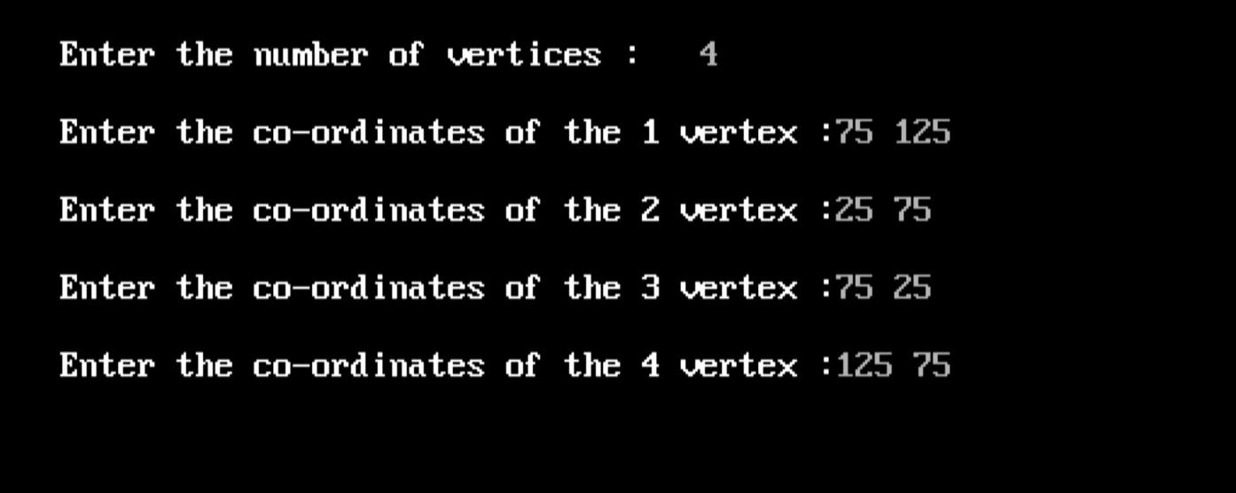

REFLECTION:

ABOUT X AXIS
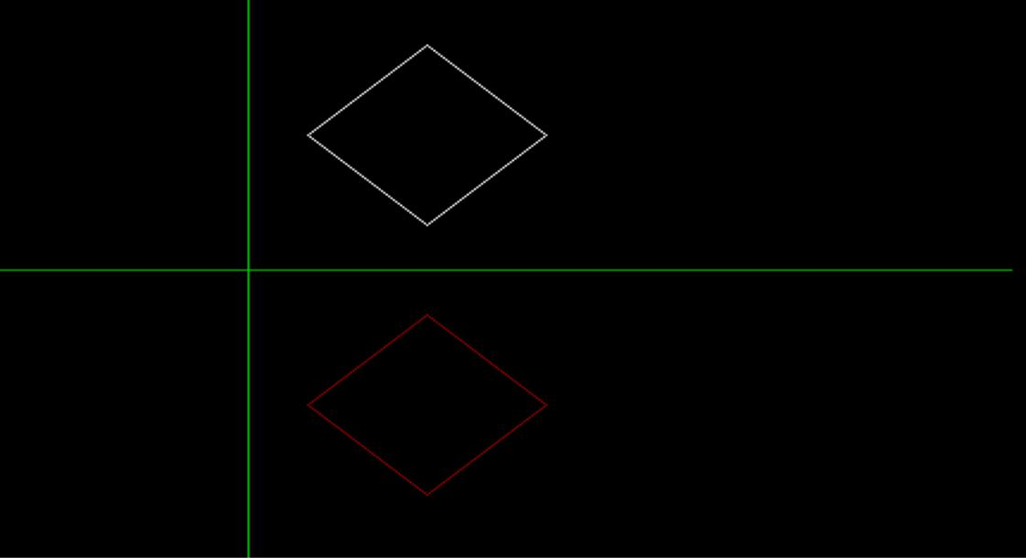

ABOUT Y AXIS
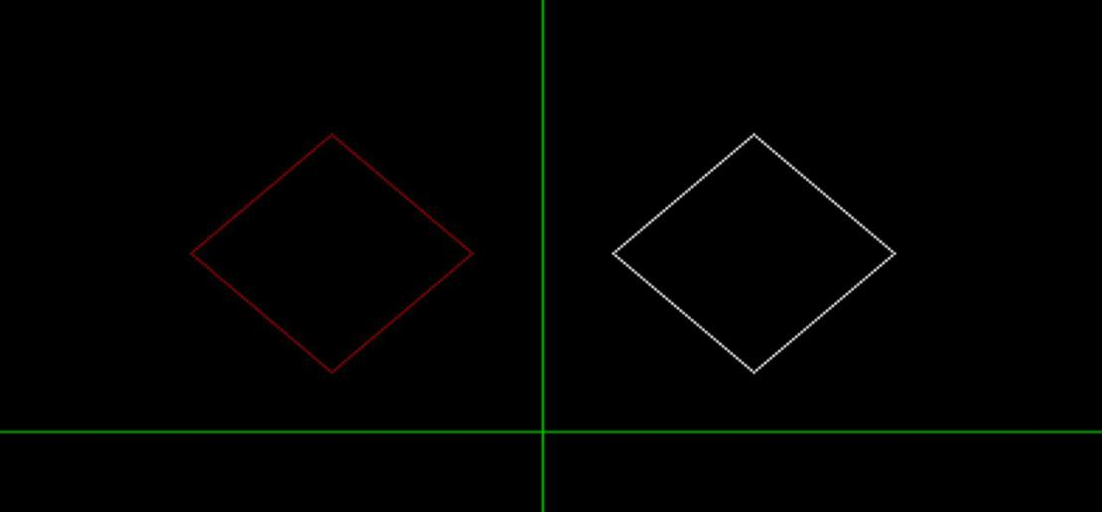
ABOUT THE ORIGIN
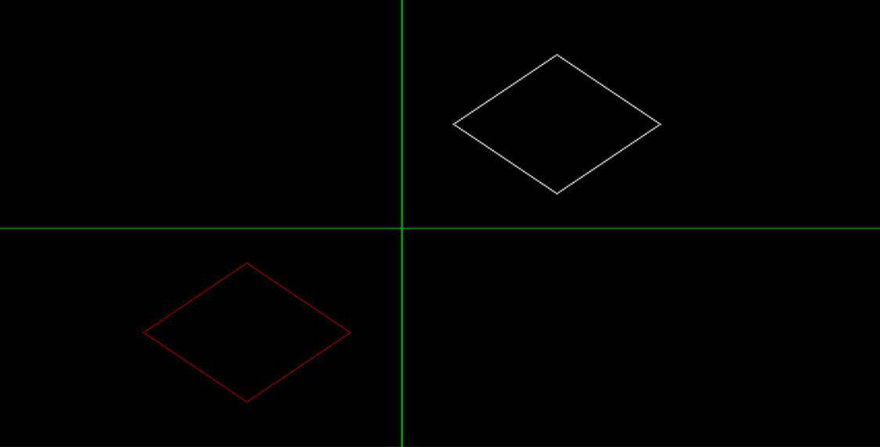

X=-Y
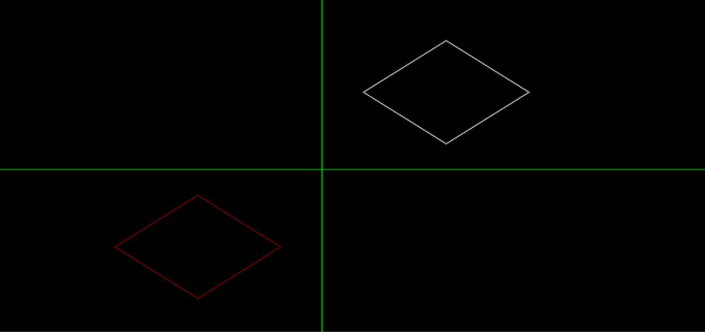

X=Y
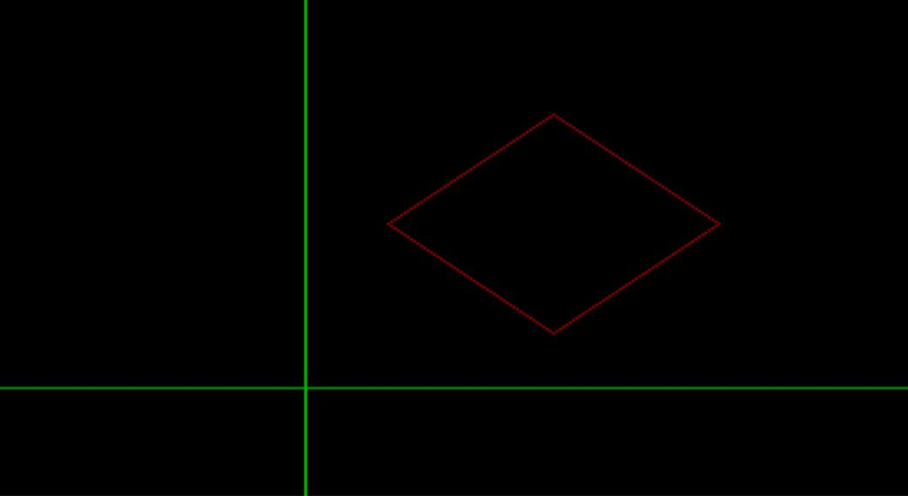
SHEARING:

X SHEAR
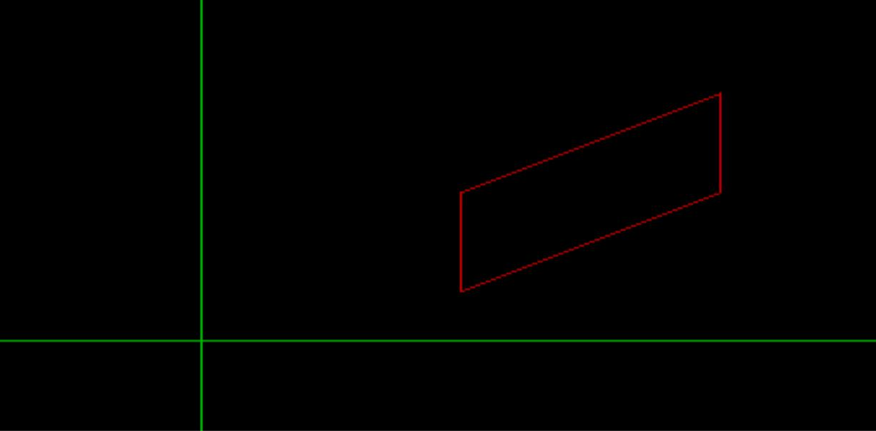

Y SHEAR
